First Generation Microprocessor
1-Introduction
Microprocessor is a digital device on a chip which can fetch instructions from a memory, decode and execute them i.e. performs certain arithmetic and logical operations, accept data from input device, and send results to output devices. Therefore, a microprocessor interfaced with memory and Input/ Output devices forms a Microcomputer.

2- Basic Microprocessor System
2.1 Address Bus
The address bus is unidirectional and is to be used by the CPU to send out address of the memory location to be accessed. It is also used by the CPU to select a particular input or output port. It may consist of 8, 12, 16, 20 or even more number of parallel lines. Number of bits in the address bus determines the minimum number of bytes of data in the memory that can be accessed. A 16-bit address bus for instance can access 216 bytes of data. It is labeled as A0…………An-1, where n is the width of bits of the address bus.
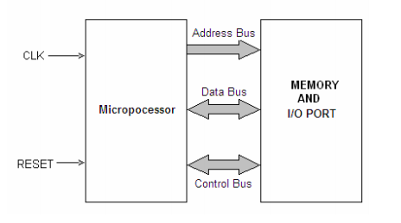
Fig. 1.2

2.2 Data Bus
Data bus is bidirectional, that is, data flow occurs both to and from CPU and peripherals. There is an internal data bus which may not be of the same width as the external data bus by that connects the I/O and memory. A microprocessor is characterized by the width of its data bus. All those microprocessors having internal and external data buses of different widths are characterized either by their internal or external data buses. The size of the internal data bus determines the largest number that can be processed by a microprocessor, for instance, having a 16-bit internal data bus is 65536 (64K). The bus is labeled as: D0 ………………Dn-1, where n is the data bus width in bits.

2.3 Control Bus
Control bus contains a number of individual lines carrying synchronizing signals. The control bus sends out control signal to memory, I/O ports and other peripheral devices to ensure proper operation. It carries control signals like MEMORY READ, MEMORY WRITE, READ INPUT PORT, WRITE OUTPUT PORT, HOLD, INTERRUPT etc. For instance, if it is desired to read the contents of a particular memory location, the CPU first sends out address of that very location on the address bus and a ‘Memory Read’ control signal on the control bus. The memory responds by outputting data stored in the addressed memory location on the data bus. This book will confine the detailed study of 8085 microprocessors because it is most commonly used microprocessor. However, evolution of microprocessors has been discussed in this chapter, in order to have the knowledge microprocessors introduced so far. Before discussing the details of the 8085, brief discussion of 8-bit microprocessor 8080 is given here.
2- Methods of I/O Operations
Memory Mapped I/O system is used in smaller system. In this system there is only one address space, some addresses are assigned to memories and some addresses to I/O devices i.e. the addresses to I/O devices are different from the addresses which have been assigned to memories. In other words, the I/O devices and memory share the memory map, with some address reserved for the I/O devices and rest for the memory. The microprocessor use R/W signals to determine the direction of data flow. The main advantage of this scheme is that it does not require additional decoding circuitry and the set of instructions may be used to fetch data either from the I/O devices or from the memory locations.

Resources
1- AN INTRODUCTION TO MICROPROCESSOR 8085, Dr. D. K. Kaushik Principal, Manohar Memorial (P.G.) College, Fatehabad (Haryana) India
2- Microprocessors and Interfacing, OXFORS university

